Robot V 1.22

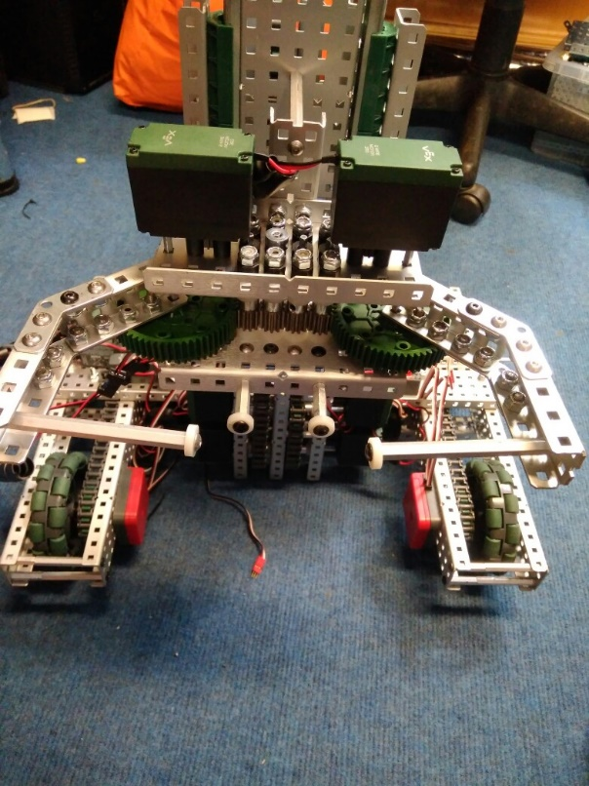

SPECIFICATIONS:

* 6 Motor HS drive
* Two drive chains
* 4 wheels
* Aluminium structure
* 4 motor lift
* Two stage lift
* 2 motor claw

DIMENTIONS:

17.5” * 15” * 17.5 when not extended

**What needs to be changed:**

* Add a third stage
* Plug in shaft encoders

By Robbie Buxton

14/7/2017 – 13:46

**Overview:**

For this version of the claw has been overhaled and we have made the transition to using standoffs as the main method of grip. We found these to be better as they are smaller meaning that the claw is more likely to get into the cone and get a stable grip. We have also added two static standoffs to help with grip.

**WHAT HAS BEEN CHANGED:**

* Improved claw
* Added shaft encoders